**Project Report**

**ON**

**Bank Management System**



***Presented by***

Sudheshna

Swathi

Tulasi

Vyshnavi

Sushmitha

**Table of Contents:**

Abstract………………………………………………………………………..3

Description……………………………………………………………………..4

Account Types…………………………………………………………………4

Current Account………………………………………………………………6

Savings Account……………………………………………………………..6

Reccuring Deposit…………………………………………………………….6

FixedDeposit………………………………………………………………….7

Loan…………………………………………………………………………..7

Lockers………………………………………………………………………..8

Software Requirements………………………………………………………….4

HardwareRequirements**………………………………………………….**4

SoftwareModel……………………………………………………….5

AgileMethodology………………………………………………..5

Programming Languages and Development tools………………………….5

Java……………………………………………………………………….5

MYSQL…………………………………………………………………...6

Non Functional Requirements……………………………………………….9

Security…………………………………………………………………..9

Quality……………………………………………………………………9

Maintainability…………………………………………………………..9

Reliability………………………………………………………………..10

ER diagram for Creating Account……………………………………………10

ER diagram for Withdraw Account……………………………………………11

Use case diagram for bank management system……………………………..13

Modules done by team members………………………………………………14

Advantages and disadvantages………………………………………………..15

Conclusion…………………………………………………………………….16

Bibliography…………………………………………………………………..17

**Abstract:**

The Bank Management system undertaken as a project is based on relevant technologies. The main aim of this project is to develop software for bank Management system. This project has been developed to carry out the process easily and quickly which is not possible with manual Systems which are overcome by this software.

**Description:**

Account transaction begins when customer is successfully logged in to the site. Several menus where displayed related to profile of customer and the recent transactions and the current account balance. The main purpose of using online account transactions is to transfer cash from one account to another for this purpose the customer is provided fields to specify the accounts to which he is transferring amount.

 After every transaction a confirmation is displayed to customer. The customer is also provided the possibility to change the account login password, but not the user id, every transaction is added to the bank database.

* Account Opening.
* Daily Transactions
* Loan
* Account Maintenance
* Search

**Account Types:**

* Savings Account
* Current account
* Fixed deposit
* Recurring deposit
* Loan
* Lockers
* Transfer of funds.

**Software Requirements:**

* JDK 1.8
* IDE(Eclipse Mars 2.0)
* My SQL(SqlYog)

**Hardware Requirements:**

* RAM(1GB)
* Hard disk(1MB)

**Software Model:**

* Agile Methodology:

In software application development, agile software development (ASD) is a methodology for the creative process that anticipates the need for flexibility and applies a level of pragmatism into the delivery of the finished product. Agile software development focuses on keeping code simple, testing often, and delivering functional bits of the application as soon as they're ready. The goal of ASD is to build upon small client-approved parts as the project progresses, as opposed to delivering one large application at the end of the project.

**Functional Requirements:**

* Create a new Account
* Delete an Account
* Update an Account
* Loans Sanctions
* Deposits
* Withdrawals

**Non-Functional Requirements:**

* Security
* Quality
* Maintainability
* Relaiable

**Programming Languages and Development tools:**

* **Java**:

Banks and financial institutions are very conservative about deciding the programming language to develop applications. There are also many instances when banks have to compensate customers to minor defects in their applications. But a number of reports have highlighted that Java is being used widely as a high performance programming language for

building a wide variety of mission critical financial applications. There are also several reasons why Java is considered by many organizations for creating banking applications.

* **MySql**

A database most often contains of one or more tables.Each table is identified by name (ex: customers or orders).Tables contains rows with data.

**Account Types:**

* **Current account**:

**Current account** is mainly for business persons, firms, companies, public enterprises etc and are never used for the purpose of investment or savings.These deposits are the most liquid deposits and there are no limits for number of transactions or the amount of transactions in a day. While, there is no interest paid on amount held in the account, banks charges certain  service charges, on such accounts. The current accounts do not have any fixed maturity as these are on continuous basis accounts.

* **Savings account:**

Savings Account is meant for saving purposes. Any individual either single or jointly can open a savings account. Most of the salaried persons, pensioners and students use Savings Account. The advantage of having Savings Account is Banks pay interest for the savings. The saving account holder is allowed to withdraw money from the account as and when required. The rate of interest ranges between 4% to 6% per annum in India. There is no restriction on the number and amount of deposits. But withdrawals are subjected to certain restrictions. Some banks recommend to maintain a minimum amount to keep it functioning.

* **Recurring deposit:**

**Recurring deposit account or RD account** is opened by those who want to save certain amount of money regularly for a certain period of time and earn a higher interest rate. In RD account a fixed amount is deposited every month for a specified period and the total amount is repaid with interest at the end of the particular fixed period. The period of deposit is minimum six months and maximum ten years. The interest rates vary for different plans based on the amount one saves and the period of time and also on banks. No withdrawals are allowed from the RD account. However, the bank may allow to close the account before the maturity period. These accounts can be opened in single or joint names. Banks are also providing the Nomination facility to the RD account holders.

* **Fixed deposit:**

In **Fixed Deposit Account** (also known as **FD Account**), a particular sum of money is deposited in a bank for specific period of time. It’s one time deposit and one time take away (withdraw) account. The money deposited in this account cannot be withdrawn before the expiry of period. However, in case of need,  the depositor can ask for closing the fixed deposit prematurely by paying a penalty. The penalty amount varies with banks. A high interest rate is paid on fixed deposits. The rate of interest paid for fixed deposit vary according to amount, period and also from bank to bank

* **Loan:**

In finance, a loan is the lending of money from one individual, organization or entity to another individual, organization or entity. A loan is a [debt](https://en.wikipedia.org/wiki/Debt) provided by an entity (organization or individual) to another entity at an [interest rate](https://en.wikipedia.org/wiki/Interest_rate), and evidenced by a [promissory note](https://en.wikipedia.org/wiki/Promissory_note) which specifies, among other things, the principal amount of money borrowed, the interest rate the lender is charging, and date of repayment. A loan entails the reallocation of the subject [asset](https://en.wikipedia.org/wiki/Asset)(s) for a period of time, between the [lender](https://en.wiktionary.org/wiki/lender) and the [borrower](https://en.wiktionary.org/wiki/borrower).In a loan, the borrower initially receives  an amount of [money](https://en.wikipedia.org/wiki/Money), called the *principal*, from the lender, and is obligated to *pay back* or *repay* an equal amount of money to the lender at a later time.The loan is generally provided at a cost, referred to as [interest](https://en.wikipedia.org/wiki/Interest) on the [debt](https://en.wikipedia.org/wiki/Debt), which provides an incentive for the lender to engage in the loan. In a legal loan, each of these obligations and restrictions is enforced by [contract](https://en.wikipedia.org/wiki/Contract), which can also place the borrower under additional restrictions known as [loan covenants](https://en.wikipedia.org/wiki/Loan_covenant).

* **Lockers:**

A locker is a small, usually narrow storage compartment. They are commonly found in dedicated cabinets, very often in large numbers, in various public places such as [locker rooms](https://en.wikipedia.org/wiki/Changing_room), [workplaces](https://en.wikipedia.org/wiki/Workplace), [middle](https://en.wikipedia.org/wiki/Middle_school) and [high schools](https://en.wikipedia.org/wiki/High_school), [transport hub](https://en.wikipedia.org/wiki/Transport_hub) and the like. They vary in size, purpose, construction, and security.

**Functional Requirements:**

|  |  |
| --- | --- |
| **Create an account** | Selecting this create a new file for the user by accepting inputs such as Account-Number, Name ,Amount |
| **Open an Account** | Open the new account for the user, by accepting the input such as Account-number ,name and minimum balance |
| **Search** | Enable to search for the details of the given account-number |
| **Deposit** | Provide option to deposit amount for the given Account-number |
| **Withdraw** | Provide option to withdraw amount for the given Account-number |
| **View Amount** | Display only one account details at a time |

**Non –Functional Requirements:**

* **Security:**

A security is a [financial instrument](http://www.investopedia.com/terms/f/financialinstrument.asp) that represents an ownership position in a [publicly-traded corporation](http://www.investopedia.com/terms/p/publiccompany.asp) ([stock](http://www.investopedia.com/terms/p/preferredstock.asp)), a creditor relationship with governmental body or a corporation ([bond](http://www.investopedia.com/terms/b/bond.asp)), or rights to ownership as represented by an [option](http://www.investopedia.com/terms/c/calloption.asp). A security is a [fungible](http://www.investopedia.com/terms/f/fungibility.asp), negotiable financial instrument that represents some type of financial value. The company or entity that issues the security is known as the issuer.

* **Quality:**

Quality management is the act of overseeing all activities and tasks needed to maintain a desired level of excellence. This includes the determination of a quality policy, creating and implementing quality planning and assurance, and [quality control](http://www.investopedia.com/terms/q/quality-control.asp) and quality improvement. It is also referred to as [total quality management](http://www.investopedia.com/terms/t/total-quality-management-tqm.asp) (TQM).

* **Maintainability:**

Maintainability is the ease with which a product can be maintained in order to: isolate defects or their cause, correct defects or their cause, repair or replace faulty or worn-out components without having to replace still working parts, make future maintenance easier.

* **Reliability:**

The term [reliability](http://whatis.techtarget.com/definition/reliability) refers to the ability of a computer-related hardware or software component to consistently perform according to its specifications. In theory, a reliable product is totally free of technical errors. In practice, vendors commonly express product reliability as a percentage.

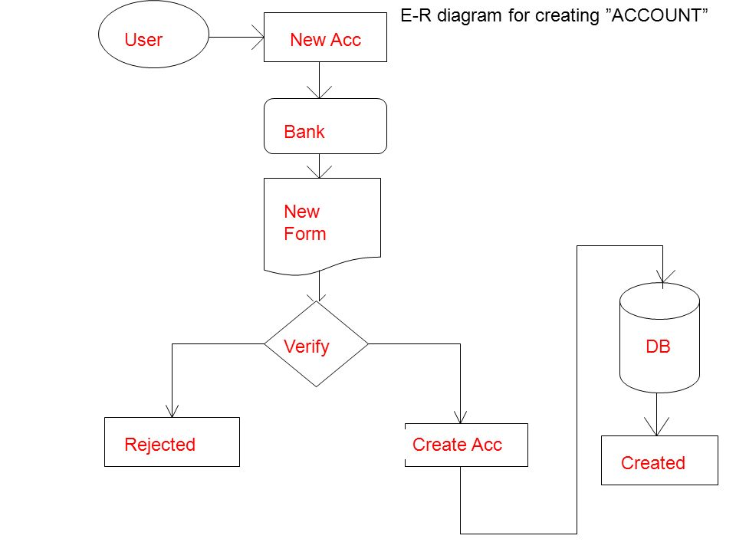

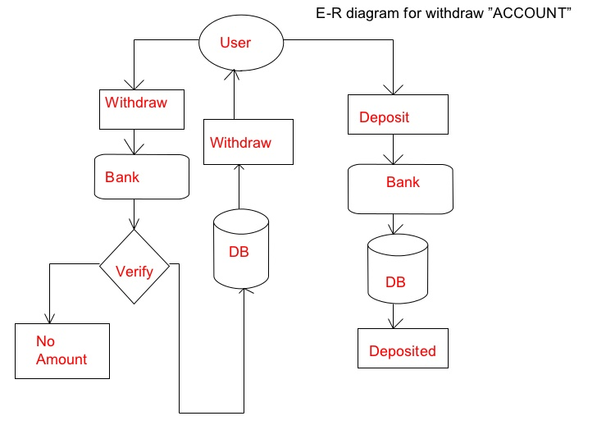

**Use case diagram for bank management system:**

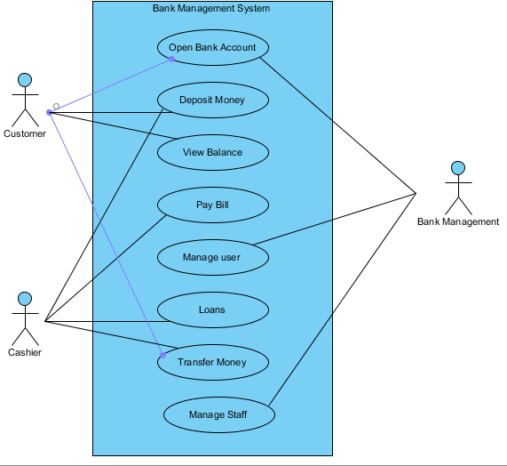

**Modules done by Team Members:**

|  |  |
| --- | --- |
| **Sudheshna**  **(Team leader)** | **Registration**  **page, Transactions ,DBA,PPT** |
| **Tulasi** | **DBA ,Deposit**  **&Withdrawalmodule, Transactions** |
| **Swathi** | **Login ,Employee module &Database connections** |
| **Vyshnavi** | **Fixed Deposit module Authentication & Authorization**  **Transfer of funds module**  **Documentation** |
| **Susmitha** | **Loan module &**  **reccuring Deposit module**  **Transfer of funds module** |

**Advantages:**

* There will be more security for your funds.
* Flow of funds through banking system will eradicate black money.
* Funds transfer is easy.
* Banks typically offer lower rates on loans.
* Banks typically provide better service; since they are owned and governed by their membership.

**Disadvantages:**

* Bank Unions are limited in their product offerings.
* One must qualify for membership.
* One must pay a membership fee to join.

**Conclusion**:

This project is developed to nurture the needs of the user in banking sector by embedding all the tasks of transactions taking place in a bank. version of this software will still be much enhanced. Thus the bank Management system is developed and executed successfully.

**Bibliography:**

* [www.google.com](http://www.google.com)
* [www.scribd.com](http://www.scribd.com)
* www.slideshare.net